

**Department of Computer Science and Engineering**

| **Course Code: CSE461** | **Credits: 1.5** |
| --- | --- |
| **Course Name: Introduction to Robotics Lab** | **Semester: Spring 23** |

**Lab 2**

**Measuring distance using ultrasonic sensor.**

# I. Topic Overview:

In this lab report, we will be discussing the process of measuring distance using an ultrasonic sensor with the help of a Raspberry Pi. Ultrasonic sensors are a common type of sensor that are used for measuring distances by sending out sound waves and measuring the time it takes for them to bounce back. Raspberry Pi is a small, affordable computer that can be used for various purposes such as programming, robotics, and education. The aim of this lab is to demonstrate how to use an ultrasonic sensor with Raspberry Pi to measure distance accurately.

# III. Learning Outcome:

After this lecture, the students will be able to:

1. Understanding the basic principles of ultrasonic sensors and how they can be used to measure distance.
2. Familiarizing oneself with the Raspberry Pi and its components, including the GPIO pins and how to connect sensors to them.
3. Learning how to install Python libraries on the Raspberry Pi and how to create and run Python programs using the terminal.
4. Gaining hands-on experience with coding in Python to measure distance using the ultrasonic sensor with the Raspberry Pi.
5. Understanding the importance of accuracy in distance measurement and how to test the accuracy of the sensor in various scenarios.
6. Acquiring problem-solving skills by troubleshooting any issues that may arise during the setup and testing process.

The Raspberry Pi 4 has 40 GPIO pins that can be easily configured to read inputs or write outputs.

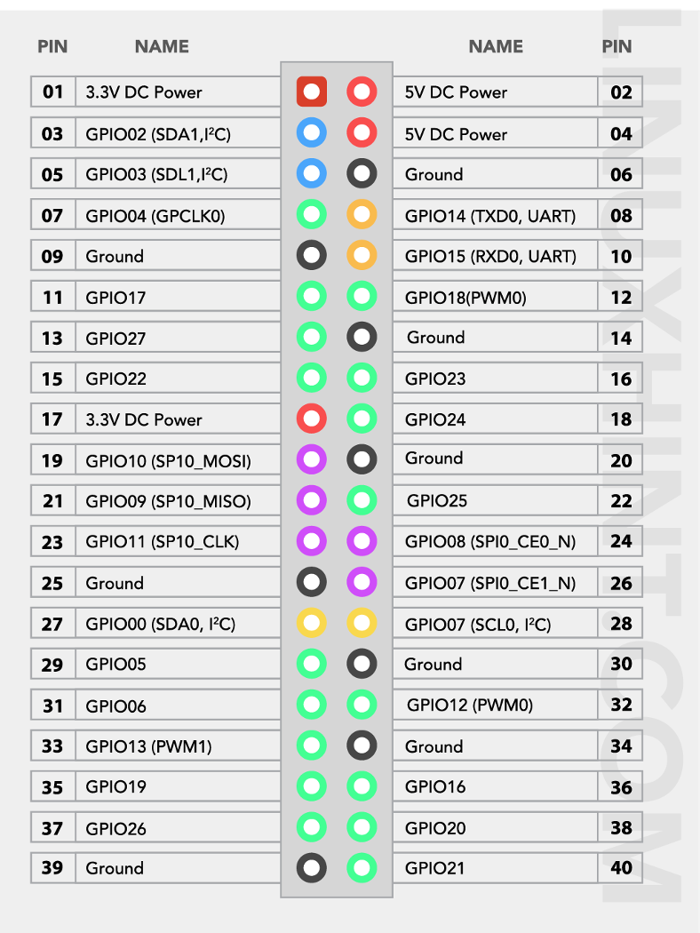

**Circuit:**

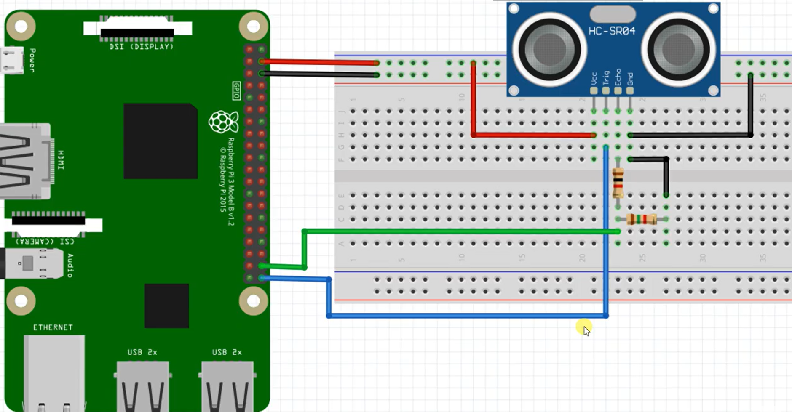

# 

**Components required for the setup:**

For controlling the LED with a push button on the Raspberry Pi 4, we need the following electronic components:

* **Raspberry Pi**
* **Ultrasonic Sensor (HC-SR04)**
* **Breadboard**
* **Jumper Wires**
* **1k and 1.5k resistor**
* **MicroSD Card**
* **USB Cable**
* **Monitor, Keyboard, and Mouse (Optional)**

**The code:**

**import RPi.GPIO as GPIO**

**import time**

**GPIO.setmode(GPIO.BCM)**

**TRIG = 21**

**ECHO = 20**

**GPIO.setup(TRIG,GPIO.OUT)**

**GPIO.setup(ECHO,GPIO.IN)**

**def distance():**

**GPIO.output(TRIG, False)**

**time.sleep(0.5)**

**GPIO.output(TRIG, True)**

**time.sleep(0.00001)**

**GPIO.output(TRIG, False)**

**pulse_start = time.time()**

**while GPIO.input(ECHO)==0:**

**pulse_start = time.time()**

**while GPIO.input(ECHO)==1:**

**pulse_end = time.time()**

**pulse_duration = pulse_end - pulse_start**

**distance = pulse_duration * 17150**

**distance = round(distance, 2)**

**return distance**

**print(distance())**

**GPIO.cleanup()**

**Lab Task**

**Explain the following questions:**

1. Why are the resistors used?